Project Report Format

# INTRODUCTION

* 1. Project Overview
  2. Purpose

# IDEATION PHASE

* 1. Problem Statement
  2. Empathy Map Canvas
  3. Brainstorming

# REQUIREMENT ANALYSIS

* 1. Customer Journey map
  2. Solution Requirement
  3. Data Flow Diagram
  4. Technology Stack

# PROJECT DESIGN

* 1. Problem Solution Fit
  2. Proposed Solution
  3. Solution Architecture

# PROJECT PLANNING & SCHEDULING

* 1. Project Planning

# FUNCTIONAL AND PERFORMANCE TESTING

* 1. Performance Testing

# RESULTS

* 1. Output Screenshots

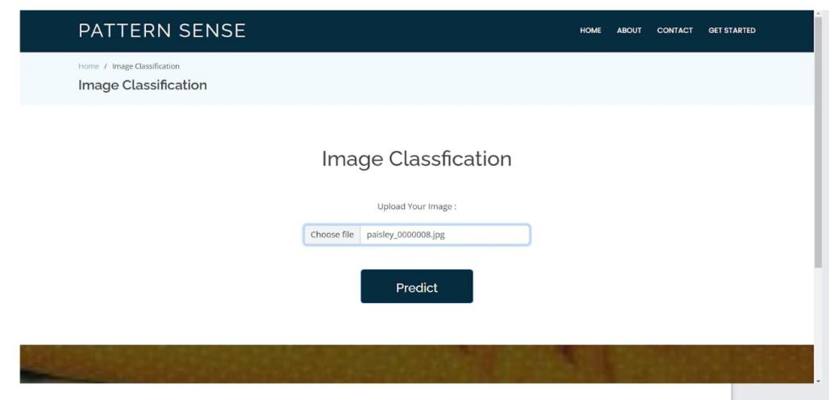

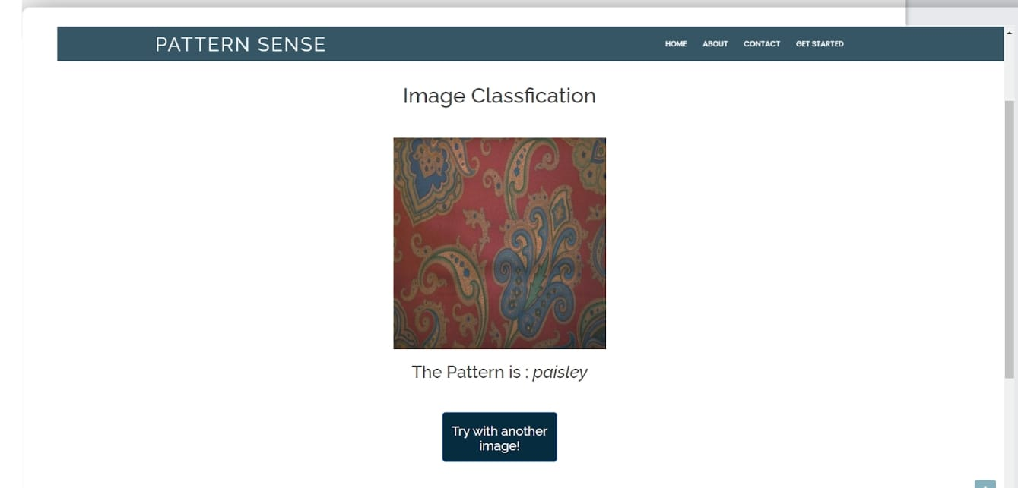

1. **ADVANTAGES & DISADVANTAGES**

**Advantages :**

a . Speed and Efficiency

b . Reliability and Consistency

c . Scalability and Flexibility

d . Practical Benefits

**Disadvantages :**

a . Data and Infrastructure Requirements

b . Technical Complexity

c . Robustness & Reliability Issues

d . Cost & Maintenance

1. **CONCLUSION :**

Fabric pattern classification using deep learning especially CNNs like ResNet has proven highly effective , achieving strong accuracy and robustness in both visible and near-infrared imaging for quality control and sustainable textile recycling. It’s is mostly useful for industries like textile , fashion and interior design.

1. **FUTURE SCOPE :**

Future progress lies in leveraging self-/unsupervised learning , multimodal sensing and optimized edge-AI deployments to build compact , real-time , data-efficient systems - paving the way for scalable , eco-friendly textile inspection and classification solutions.

1. **APPENDIX**

Dataset Link : <https://www.kaggle.com/datasets/nguyngiabol/dress-pattern-dataset>

GitHub Link : <https://github.com/LalithaGolla05/Pattern-Sense>

Project Demo Link :

https://drive.google.com/file/d/1zyc93f8CeKJOTgmvPZIz4DWintObO6MM/view?usp=drive_link